***CODE TESTING***

**AUTOMATED ATTENDANCE SYSTEM**

**TEAM JAK OF ALL TRADES**

**Members:**

Allen Jean B. Lagangga

Jessa M. Diano

Kent Christian Lurado

***May 20, 2025***

1. **Register Testing**

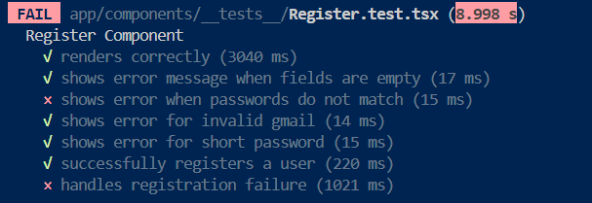 **Fail:**

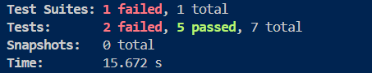

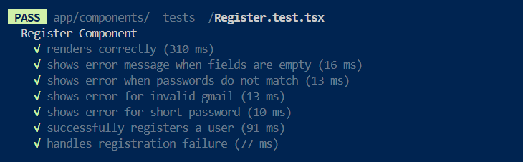 **Success:**

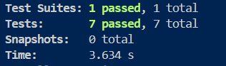

1. **Sign In Testing**

**Fail:**

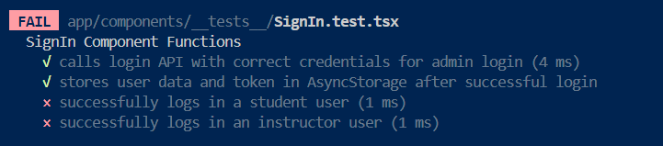

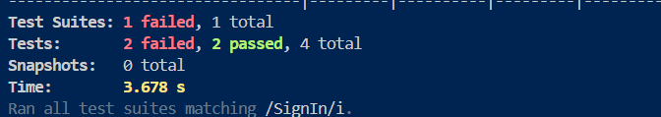

**Success**

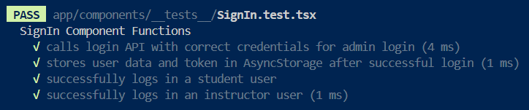

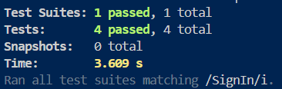

1. **Instructor Registration Testing**

**Fail:**

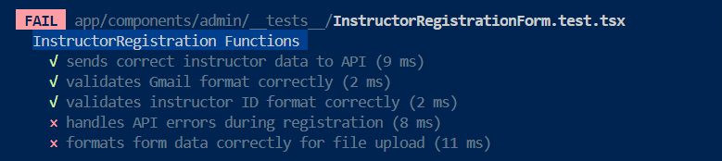

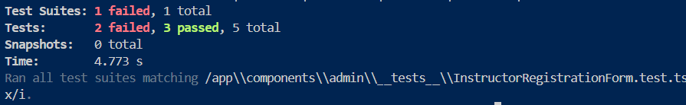

**Success:**

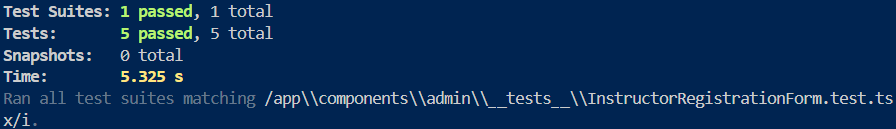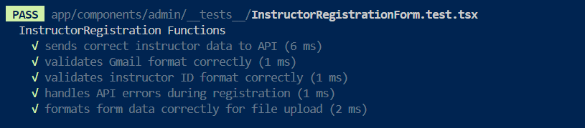

1. **Student Registration Testing**

**Fail:**

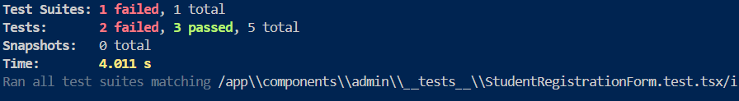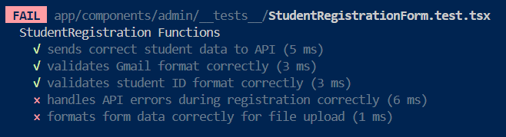

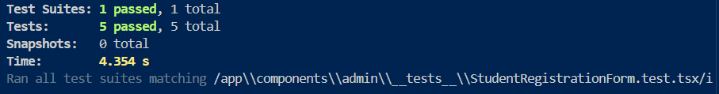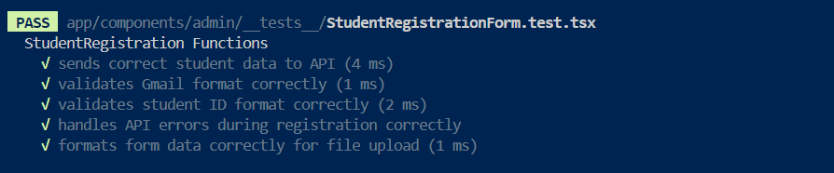 **Success:**

1. **Instructor Management Testing**

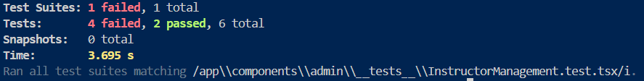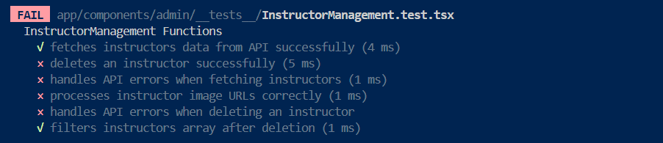 **Fail:**

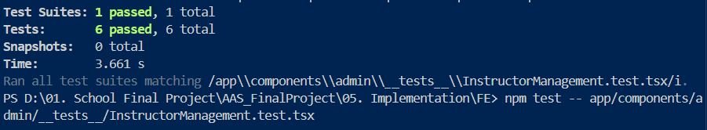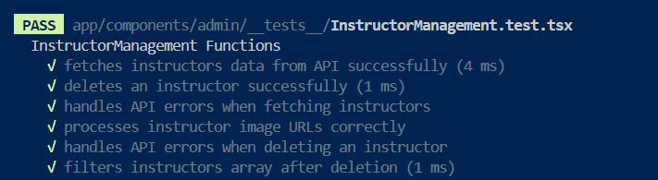 **Success:**

1. **Student Management Testing**

**Fail:**

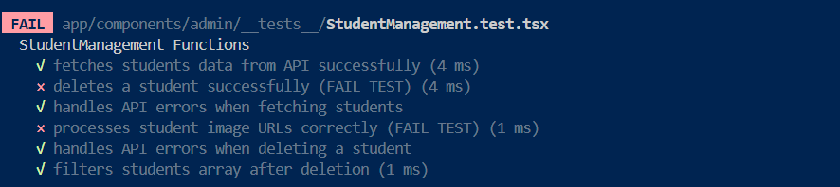

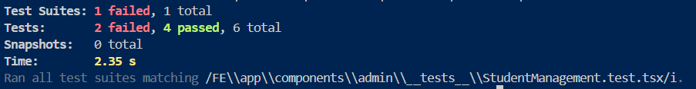

**Success:**

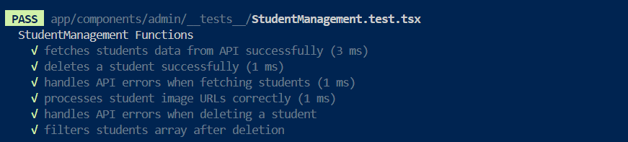



1. **Course Registration Testing**

**Fail:**

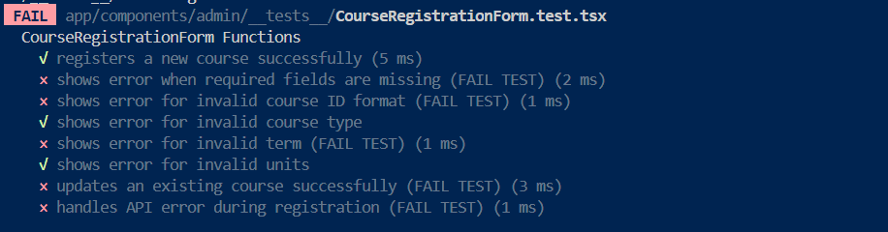

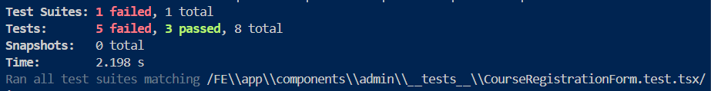

**Success:**

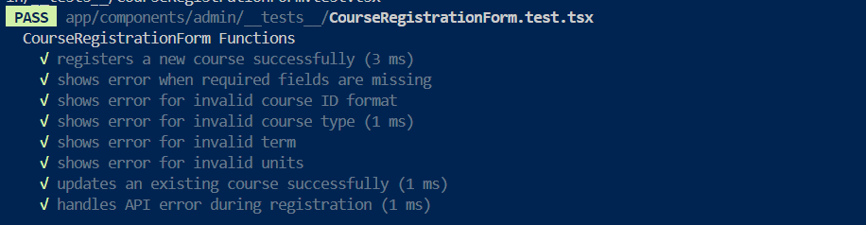

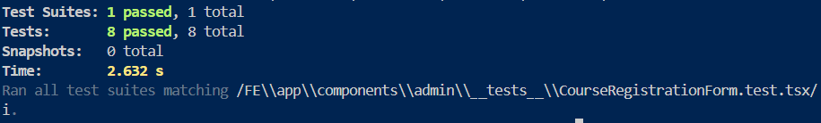

1. **Course Management Testing**

**Fail:**

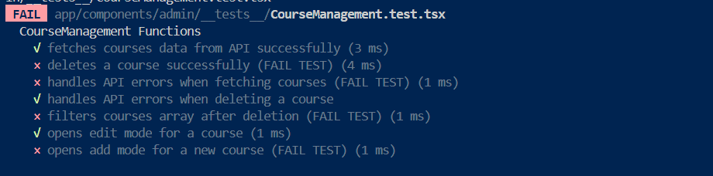

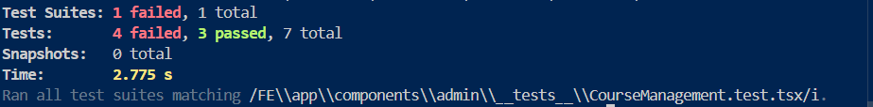

**Success:**

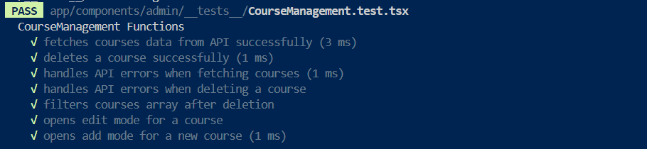

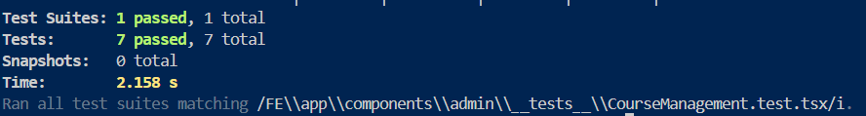

1. **Assign Courses Testing**

**Fail:**

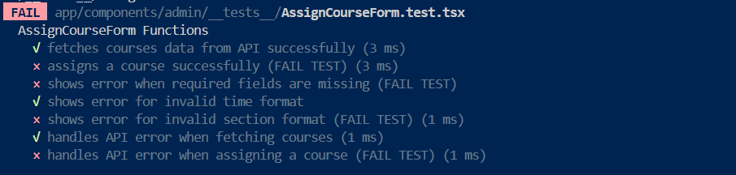

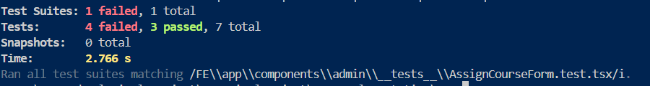

**Success:**

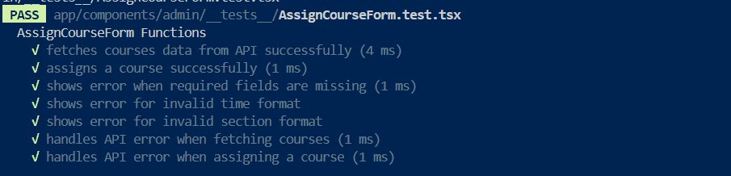

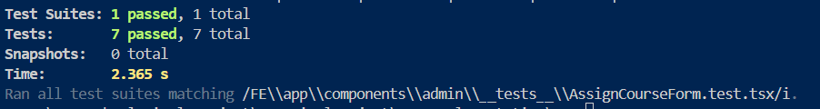

**10. Enroll Student Testing**

**Fail:**

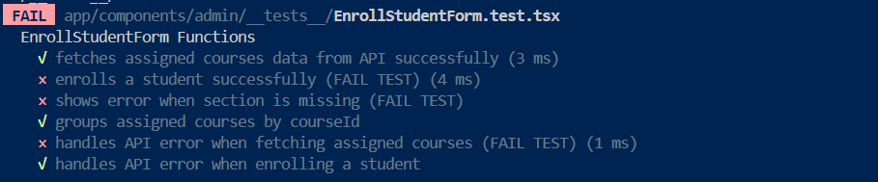

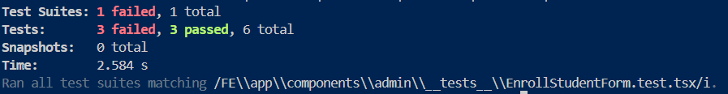

**Success:**

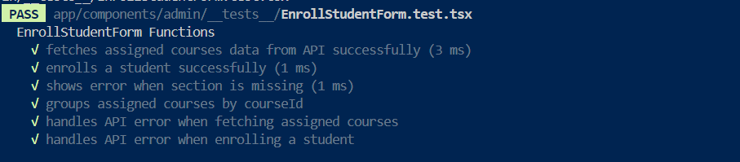

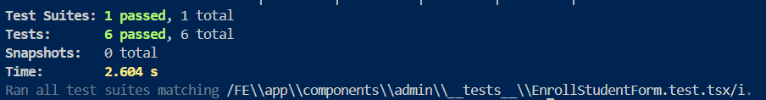

**11. QR Code Generator Testing**

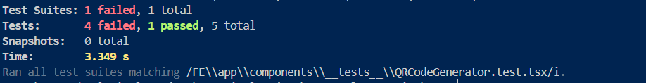 **Fail:**

**Success:**